The Ohio State University

Colleges of the Arts and Sciences New Course Request

Department of Geological Sciences

Academic Unit
Geological Sciences

Book 3 Listing (e.g., Portuguese)
420 Global Oil and Gas Production, Occurrence, and Movement
Number Title
Global Oil and Gas U 05
18-Character Title Abbreviation Level Credit Hours

Summer Autumn Winter Spring X Year 2007
Proposed effective date, choose one quarter and put an “X” after it; and fill in the year. See the OAA curriculum manual for deadlines.

A. Course Offerings Bulletin Information

Follow the instructions in the OAA curriculum manual. If this is a course with decimal subdivisions, then use one New Course Request form for the generic information that will apply to all subdivisions; and use separate forms for each new decimal subdivision, including on each form the information that is unique to that subdivision. If the course offered is less than a quarter or a term, please complete the Flexibly Scheduled/Off Campus/Workshop Request form.

Description (not to exceed 25 words): The origin, migration, accumulation, exploration, and exploitation of oil and

gas deposits within an historical context of the evolving global petroleum economy.

Quarter offered: Spring Distribution of class time/contact hours: 3, 2-hr classes/wk
Quarter and contact/class time hours information should be omitted from Book 3 publication (yes or no): No

Prerequisite(s): GEC data analysis course; sophomore standing and above

Exclusion or limiting clause:

Repeatable to a maximum of __NA___ credit hours.

Cross-listed with:

Grade Option (Please check): Letter S/U Progress What is course is last in the series? ______

Honors Statement: Yes No X GEC: Yes No X Admission Condition
Off-Campus: Yes No X EM: Yes No X Course: Yes No X

Other General Course Information:
(e.g. “Taught in English.” “Credit does not count toward BSBA degree.”)

B. General Information

Subject Code________________________ Subsidy Level (V, G, T, B, M, D, or P)___________________________
If you have questions, please email Jed Dickhaut at dickhaut.1@osu.edu.

1. Provide the rationale for proposing this course:

2. Please list Majors/Minors affected by the creation of this new course. Attach revisions of all affected programs. This course is (check one): Required on major(s)/minor(s) XA choice on major(s)/minors(s)
An elective within major(s)/minor(s) A general elective:

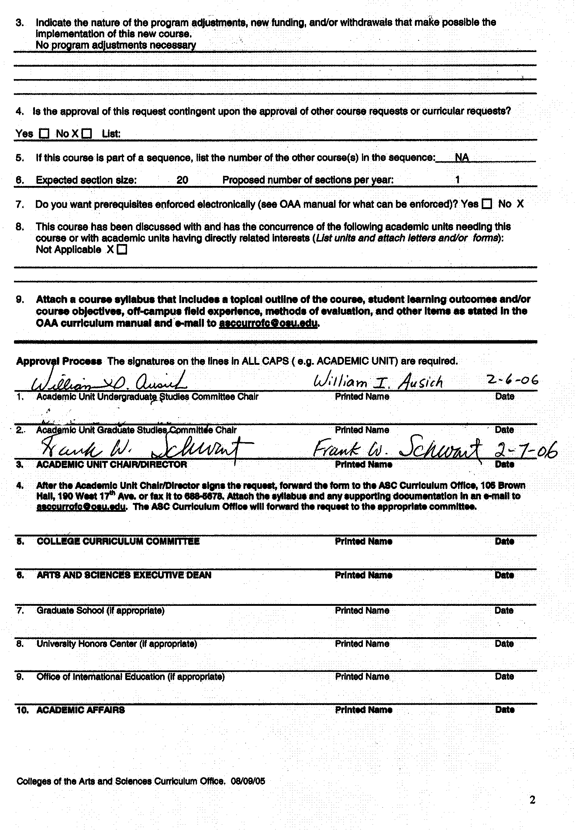

Dept of Geological Sciences 420

Global Oil and Gas Production, Occurrence, and Movement

Rationale: People use oil and gas more than any other energy resource. From crude oil, refineries make or extract gasoline, diesel fuel, jet fuel, heating oil, and lubricants; and petrochemical plants manufacture plastics and fertilizers. Natural gas is used to heat our homes and fire steam generators to produce electricity. Few commodities more directly or indirectly affect the citizens and nations of the world. Over the past century, economies of Western nations have developed explosively, fueled by cheap energy from fossil fuels. However, current world events emphasize the tenuousness of these oil and gas sustained economies. Decreased production and uncertain future production have lead to sharply rising prices for energy, and may be just the precursor to a cascade of impacts on our affluent lifestyles. In this class, students will examine a spectrum of topics on the origin, location, migration, accumulation, exploration, and exploitation of oil and gas deposits. With this increased technical insight, they will develop a thorough appreciation of the science and technology needed to find more reserves, and the knowledge to critically and factually assess possible alternative energy resources.
There is a need for all students to better understand the geology of petroleum. This undergraduate level course on global oil and gas production, occurrence, and movement will provide students with the basic foundation and broader perspective required for other courses in the geological sciences. Also, it and related courses are specifically intended to form a background appropriate for employment in the petroleum industry. Students outside the geological sciences will benefit from this introductory-level course by development of the technological knowledge necessary to comprehend and evaluate global oil and gas issues. It is anticipated that enrollment for this course will grow steadily from less than 10, to 20 or more with increasing departmental and university exposure.

NEW COURSE SYLLABUS

College of the Arts and Sciences
Department of Geological Sciences
Course Number/Title: 420 Global Oil and Gas Production, Occurrence, and Movement

Instructor/Lectures: Dr. Scott Bair

Graduate Teaching Associate: TBD

Required Text/Reading List: North, F. K., 1985. Petroleum Geology. Allen & Unwin,
London, England, 607 p.

Yergin, D., 1991. “The Prize – The Epic Quest for Oil,
Money & Power,” Free Press, New York, N.Y., 883 p.

Credit: 5 Credit Hours

Prerequisite: GEC data analysis course; sophomore standing and above

Course Structure: Three, 2-hour classes/wk

Description: The origin, migration, accumulation, exploration, and exploitation of oil and gas deposits are presented within a historical context of the evolving global petroleum economy.

Content: This course provides a broad introduction to the technology and issues surrounding global oil and gas production, occurrences, and movement. A wide range of topics will address not only the history and impacts of global production through time and can the petroleum economy be sustained; but also the origin of petroleum; characteristics of source rocks, petroleum basins, reservoir rocks, caprocks, and traps; exploration, exploitation and forecasting; secondary recovery techniques; and how and what petroleum products are refined. Lectures, readings, demonstrations, class projects and assignments, and local field trips will encourage students to develop a local, national, and global perspective on petroleum resources and the petroleum industry. The PBS series “The Prize”, based on the award-winning book of the same title, will be interwoven throughout the course.

Course Objectives: The objective of this course is to introduce students to the history of petroleum production, including the significant role of Ohio, the development of the petroleum economy, including John Rockefeller and his Standard Oil Company of Ohio, the geochemical
mechanisms creating oil, the physics of oil migration and accumulation, the characteristics of oil reservoirs around the world, the tools and techniques used to explore for oil and extract it from the
ground. Upon completion, students will have a thorough understanding of the global distribution of oil resources, an appreciation for science and technology needed to find more oil, and a sense of the history of oil and gas production as it evolved from Titusville, Pennsylvania, to Findlay, Ohio, to Beaumont, Texas, and then around the world.

Course Grades: Based on two midterm exams (40%), homework problems (20%), class project (20%), and comprehensive final exam (20%).

Policies on Attendance and Absences: Attendance is required at all lecture sessions. The instructor should be notified as soon as possible in emergency situations where students must miss class. The deadline for make-up work for missed assignments, quizzes or examinations is one (1) week from the original date of administration. Each student must meet individually with the instructor regarding make-up work for missed assignments.

Disability Services: Students with disabilities that have been certified by the Office for Disability Services will be appropriately accommodated, and should inform the instructor as soon as possible of their needs. The Office for Disability Services is located in 150 Pomerene Hall, 1760 Neil Avenue (telephone 292-3307, TDD 292-0901, http://www.ods.ohio-state.edu/).

Academic Misconduct: The Ohio State University and the Committee on Academic Misconduct (COAM) expect that all students will complete all academic and scholarly assignments with fairness and honesty. Failure to follow the rules and guidelines established in the University’s Code of Student Conduct and this syllabus may constitute “Academic Misconduct”.
The Ohio State University’s Code of Student Conduct (Section 3335-23-04) defines academic misconduct as: “Any activity that tends to compromise the academic integrity of the University, or subvert the educational process”. Examples of academic misconduct include (but are not limited to) plagiarism, collusion (unauthorized collaboration), copying the work of another student, and possession of unauthorized materials during an examination. All suspected cases of academic misconduct will be reported to the University Committee on Academic Misconduct. If academic misconduct has been committed, possible sanctions could include a failing grade in this course and suspension or dismissal from the University.

Topical Outline: The following is a tentative, chronological outline of course lecture topics:

- The petroleum economy: how we got where we are today; global production through time; sizes of fields and the global impacts of new discoveries. [Tie in history of Colonel Drake’s 1856 well in Titusville, Pennsylvania, plus the Trenton oil boom in the 1880s in NW Ohio.]

- What is petroleum, how is it refined, and what products are produced by refining. [Virtual tour of the BP refinery in Lima, Ohio.]

- How petroleum is created; oil maturation; age of reservoirs; chemical characteristics of oil, gas, and tar sands. [Tie in geologic and geochemical settings of the famous Oil Creek field in western Pennsylvania, the Trenton fields in NW Ohio, and the Spindletop fields in Beaumont Texas.]

- Characteristics of source rocks, processes, and factors in petroleum migration and accumulation. [Darcy’s Law demonstration; regional flow demonstration in sand tank.]

- Characteristics of petroleum basins, reservoir rocks, caprocks, and traps. [Carbonate reservoirs in Saudi Arabia, sandstones in Venezuela, Cenozoic sediments in the Gulf Coast and North Sea; field trip to Ohio Geological Survey’s Core Storage Lab at Alum Creek State Park.]

- Characterization of reservoirs: drill-stem testing, repeat formation testing, pressure-depth relations. [Examples from Battelle carbon sequestration well in Virginia.]

- Secondary recovery techniques

- Exploration, exploitation, and forecasting. [Use of seismic lines and 3-D seismic, costs of exploration and drilling, pipelines, and petroleum products.]

- Can the petroleum economy be sustained? [Tie back to Drake, Rockefeller, Nobel, and Rothschild; oil booms in Ohio history; and M. K. Hubbert’s predictions.]

